|  |  |  |
| --- | --- | --- |
| Image result for latest marwadi university logo | **Marwadi University**  **Faculty of Technology**  **Department of Information and Communication Technology** | |
| **Subject:- IRRS(01CT0106)** | Aim:- Shark Tank Data Analysis | |
| **Long Hour Coding** | **Date:-**  08-05-2023 | **Enrolment No:-** 92200133030 |

**Prerequisites:-**

1. Reading Data Set



1. 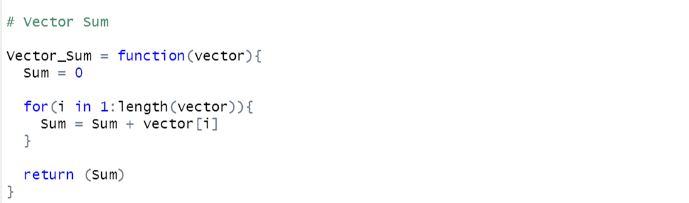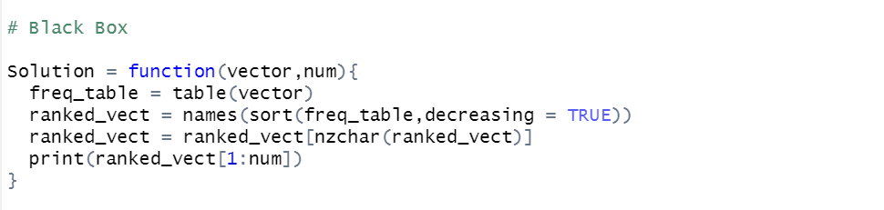Functions:-

**Question-1**

**Aim:-** Which season is having the overall highest deal in terms of the amount?

**Code:-**



**Output:-**

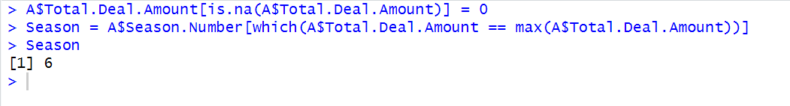

**Question-2**

**Aim:-** Enlist episodes for each season having the highest deal in terms of the amount?

**Code:-**

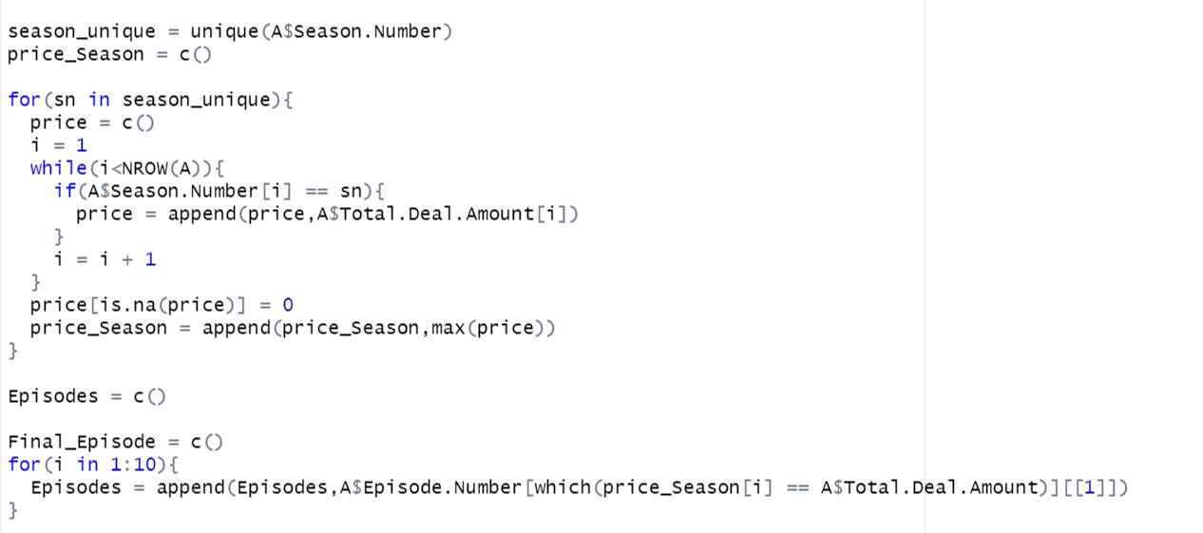

**Output:-**

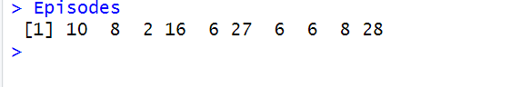

**Question-3**

**Aim:-** Which are the top-10 deals in the shark tank?

**Code:-**

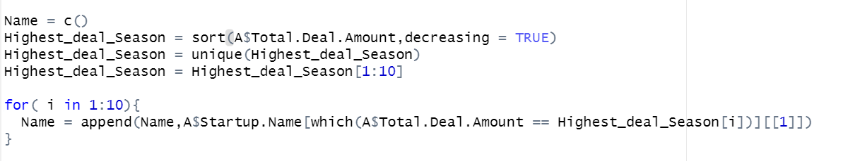

**Output:-**

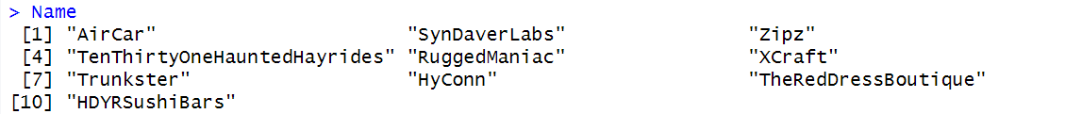

**Question-4**

**Aim:-** Top-3 Industries with highest deals in the shark tank?

**Code:-**

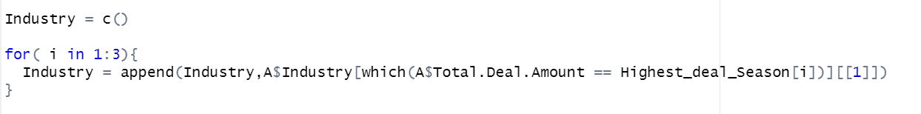

**Output:-**



**Question-5**

**Aim:-** Which are the top-5 cities with the maximum number of entrepreneurs?

**Code:-**



**Output:-**



**Question-6**

**Aim:-** Which are the top-3 states that has got maximum number of deals?

**Code:-**

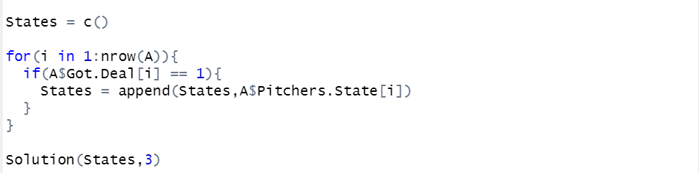

**Output:-**



**Question-7**

**Aim:-** Industry wise count the total number of startups who pitched in shark tank?

**Code:-**

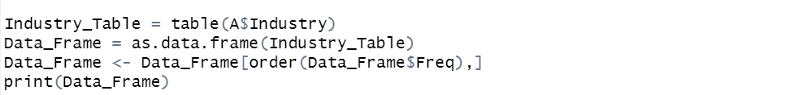

**Output:-**

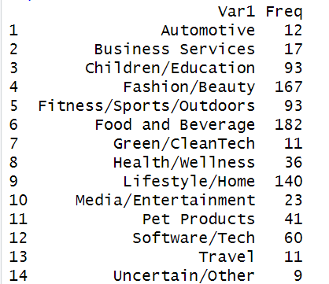

**Question-8**

**Aim:-**  Count the number of pitchers who are male, female and belongs to mixed team?

**Code:-**

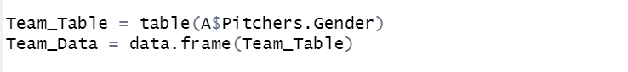

**Output:-**

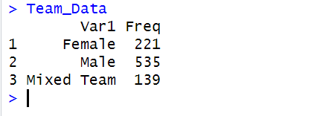

**Question-9**

**Aim:-** Find the maximum amount requested by a pitcher in each industrial segment?

**Code:-**

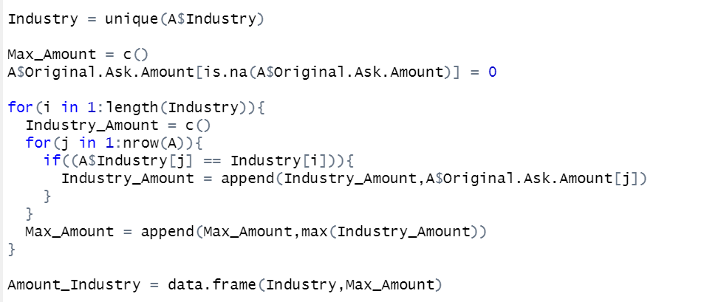

**Output:-**

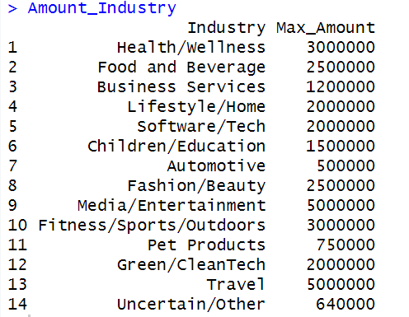

**Question-10**

**Aim:-** Find the maximum equity received by a shark in each industrial segment

**Code:-**

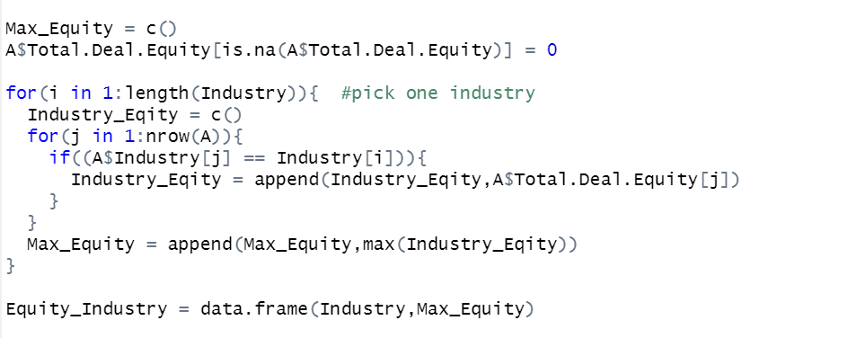

**Output:-**

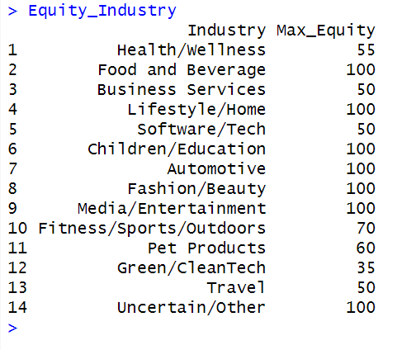

**Question-11**

**Aim:-**  Find the total amount invested by each shark throughout shark tank?

**Code:-**

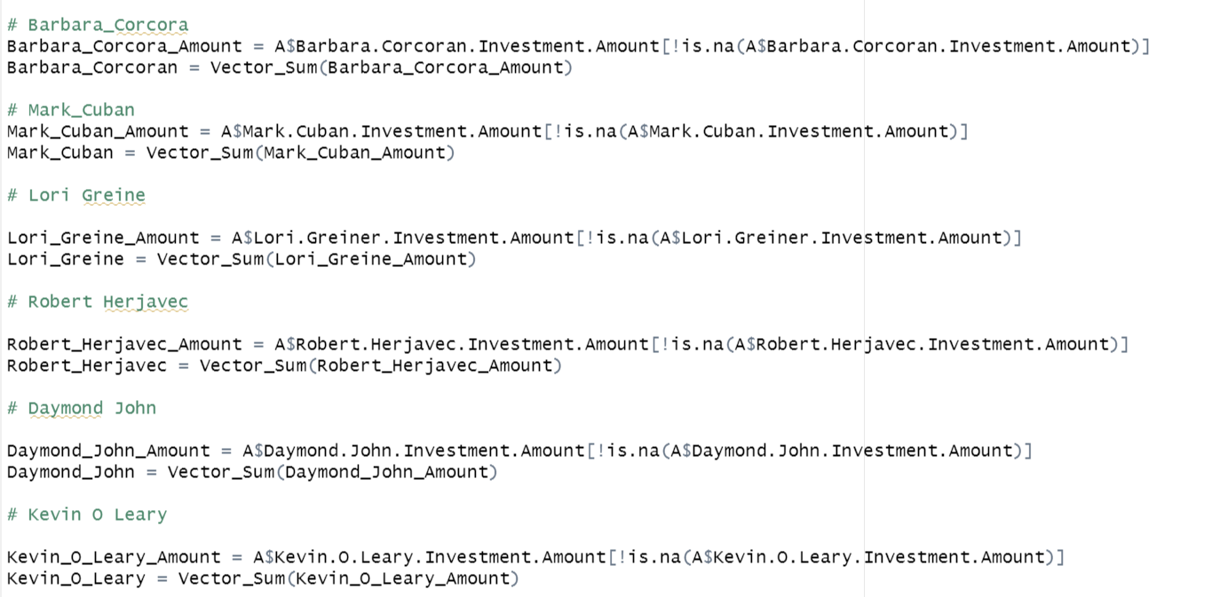



**Output:-**

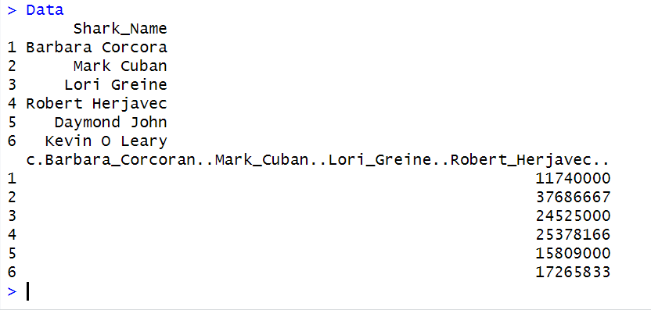

**Question-12**

**Aim:-** Name the startups with Top-15 investments

**Code:-**

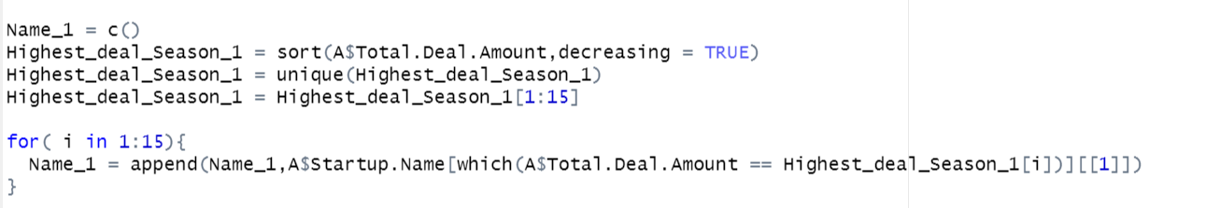

**Output:-**

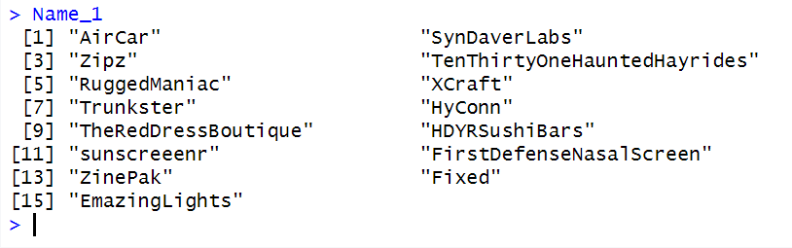

**Question-13**

**Aim:-** Find number of deals having [1,2,3,4,5] sharks included in the deal?

**Code:-**

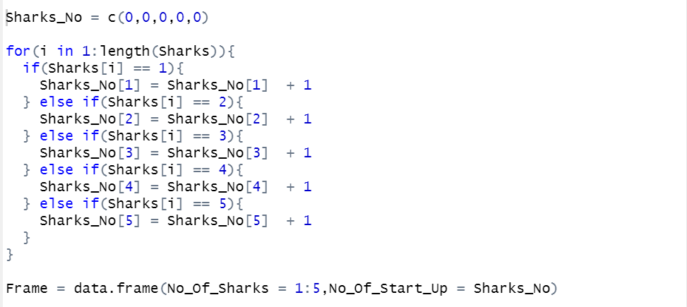

**Output:-**

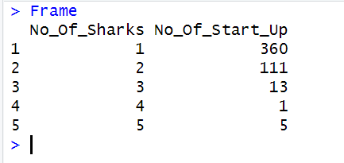

**Question-14**

**Aim:-** Which are the top-3 industries where "Kevin O Leary" is more interested to invest into?

**Code:-**

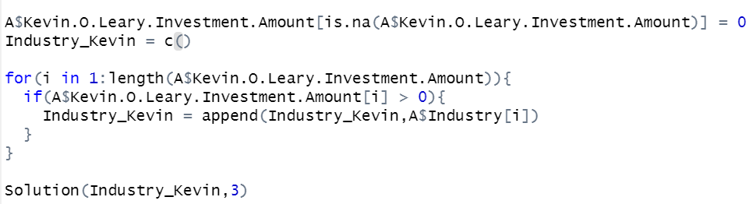

**Output:-**



**Question-15**

**Aim:-**  Which are the 3 least favoured industries by the sharks?

**Code:-**

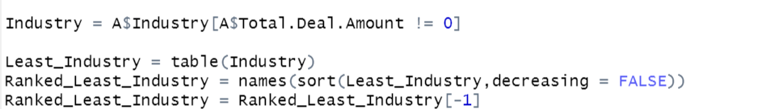

**Output:-**

